

**Faculty of engineering - Shoubra**

**Benha University**

# Research Article / Research Project / Literature Review

in fulfillment of the requirements of

|  |  |  |
| --- | --- | --- |
| **Department** | **Engineering Mathematics and Physics** | |
| **Division** | **-------------------** |
| **Academic Year** | **2019-2020 Preparatory** |
| **Course name** | **Computer** |
| **Course code** | **ECE001** |

## Title: -

**Build a website on recent computer engineering topics**

By:

|  |  |  |  |
| --- | --- | --- | --- |
|  | Name | Edu mail | B.N |
| 1 | Zainab Gharib Ahmad | zainab195419@feng.bu.edu.eg | 376 |

**Approved by:**

|  |  |
| --- | --- |
| Examiners committee | Signature |
| **Dr.Ahmed Bayoumi** |  |
| **Dr.Shady Elmashad** |  |
| **Dr. Abdelhamid Attaby** |  |

# Literature Review

# Programming language

Computer programming language, any of various languages for expressing a set of detailed instructions for a digital computer. Such instructions can be executed directly when they are in the computer manufacturer-specific numerical form known as machine language, after a simple substitution process when expressed in a corresponding assembly language, or after translation from some “higher-level” language. Although there are many computer languages, relatively few are widely used.

Machine and assembly languages are “low-level,” requiring a programmer to manage explicitly all of a computer’s idiosyncratic features of data storage and operation. In contrast, high-level languages shield a programmer from worrying about such considerations and provide a notation that is more easily written and read by programmers.

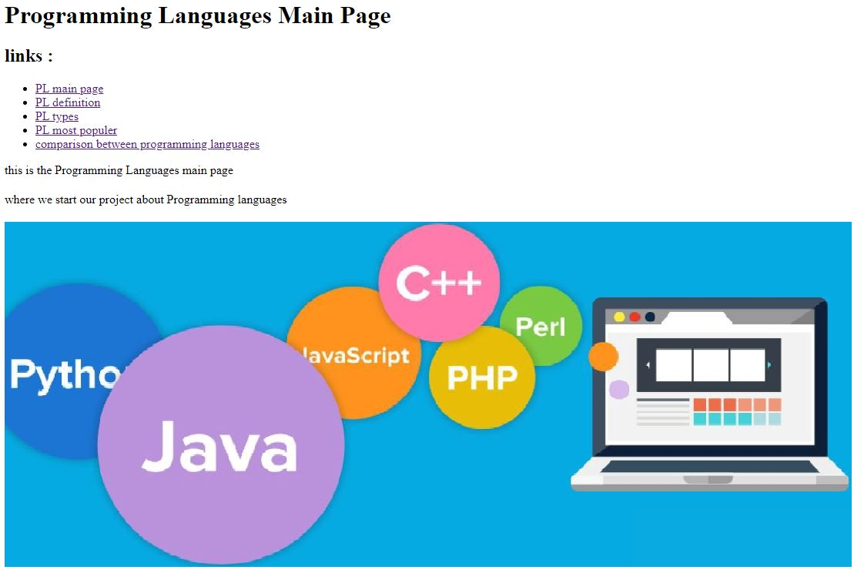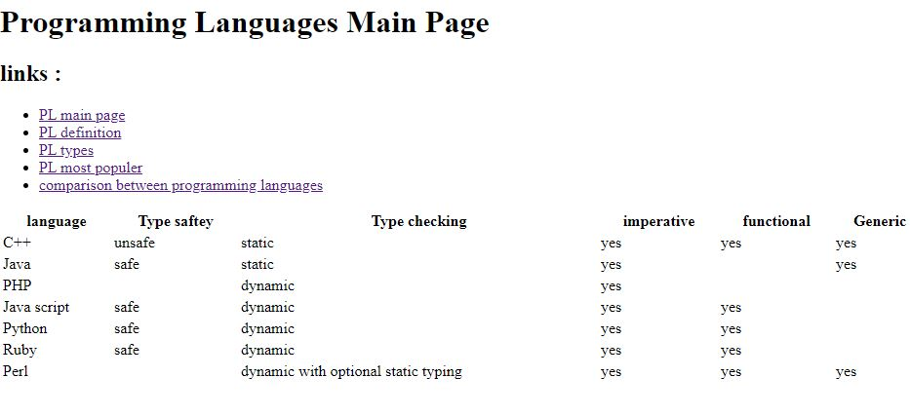

Figure 2

Figure 1

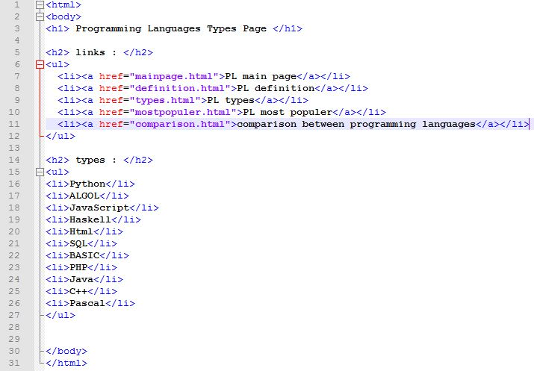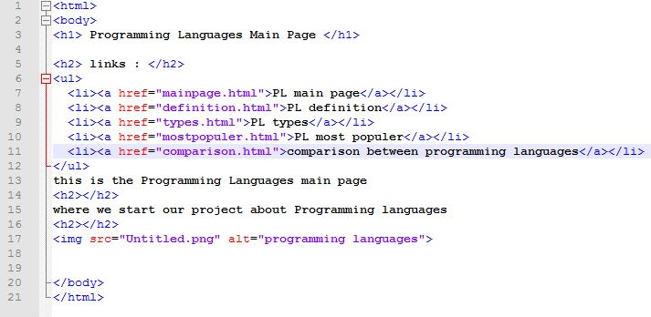\

Figure 4

Figure3

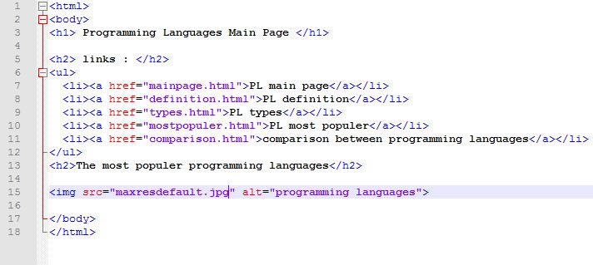

Figure 5